- Name the two types of complex permanent tissues found in plants.
- Name the tissue responsible for the transport of water and minerals in plants.
- Name the tissue that transports food from leaves to other parts of the plant.
- Mention one main component of xylem.
- Mention one main component of phloem.
- State one function of xylem.
- State one function of phloem.
- Name the living component of xylem.
- Name the dead component of phloem.
- Mention the main function of sieve tubes in phloem.
- Leaves begin to wilt after damage to a particular tissue. Identify the tissue likely affected and give a reason.
- A ring of bark is removed from the stem of a plant. After some time, food accumulates above the ring. Identify the tissue involved and explain the reason.
- Xylem contains both living and dead cells, yet it efficiently transports water. Justify this statement.
- A plant has healthy leaves but its roots cannot receive sufficient food. Identify the tissue that may be damaged and explain your reasoning.
- Compare xylem and phloem on the basis of material transported, direction of transport, and nature of their cells.
Diagram Based Question - Answer the following questions on the basis of the Picture given:
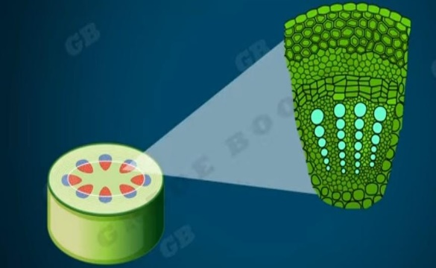
- Identify the cross section shown in the picture.
- Label and name the section of the tissues that conduct water and minerals from the roots to leaves of the plant.
- Why are those tissues called complex?
- Which part of a leaf are these tissues present?
- Write the names of the four elements of the tissue that are present in the tissues that transport prepared food to different parts of the plant from the leaves.

